**Enabling Http Even Collector in Splunk**

Login to Splunk

Go to Settings -> Data Inputs -> Http Event Collector

Click on Global Settings

Beside ‘All Tokens’ click on Enable Button and hit Save

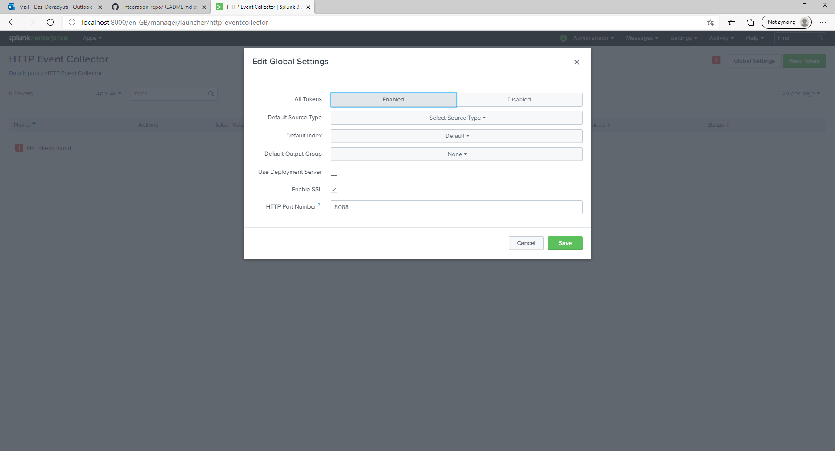

**Click Data Entry for Http Event**

Go to Settings -> Add Data

Click Monitor -> Http Event Collector

Populate name and optional source name, description and click Next

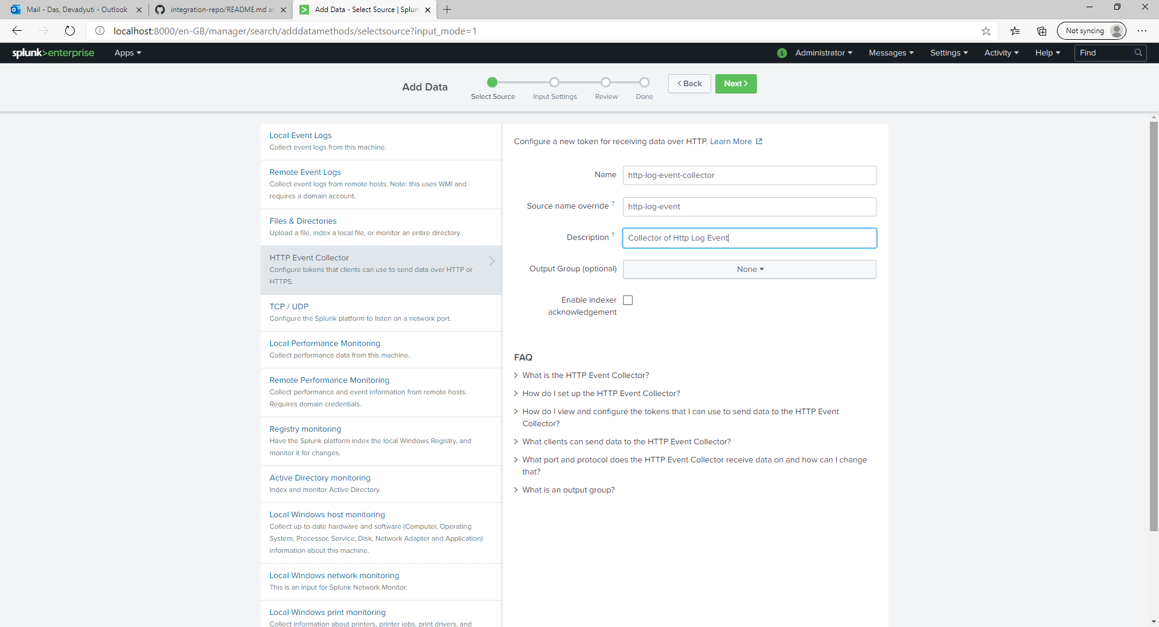

Select Source Type as Structured -> _json

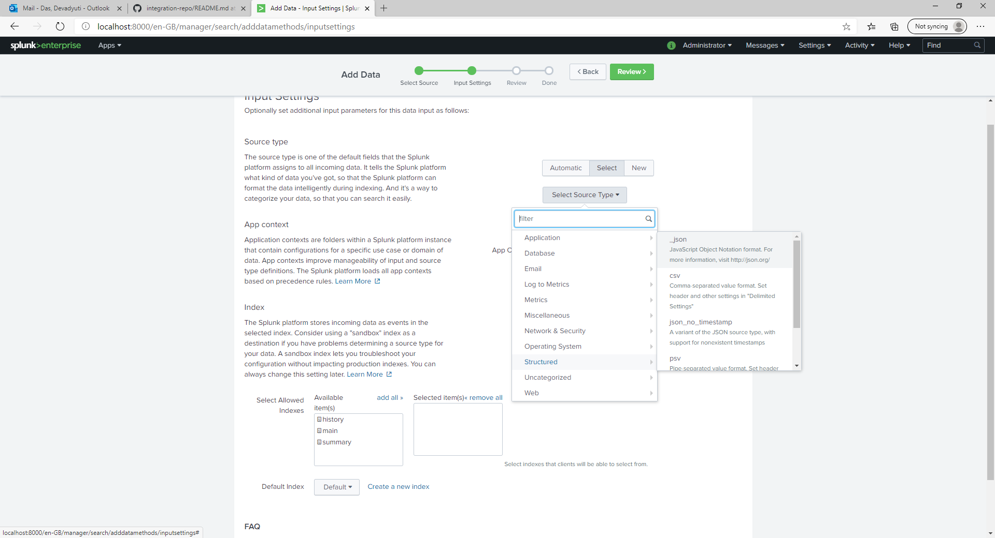

Create a new Index. Enter name and click on Save.

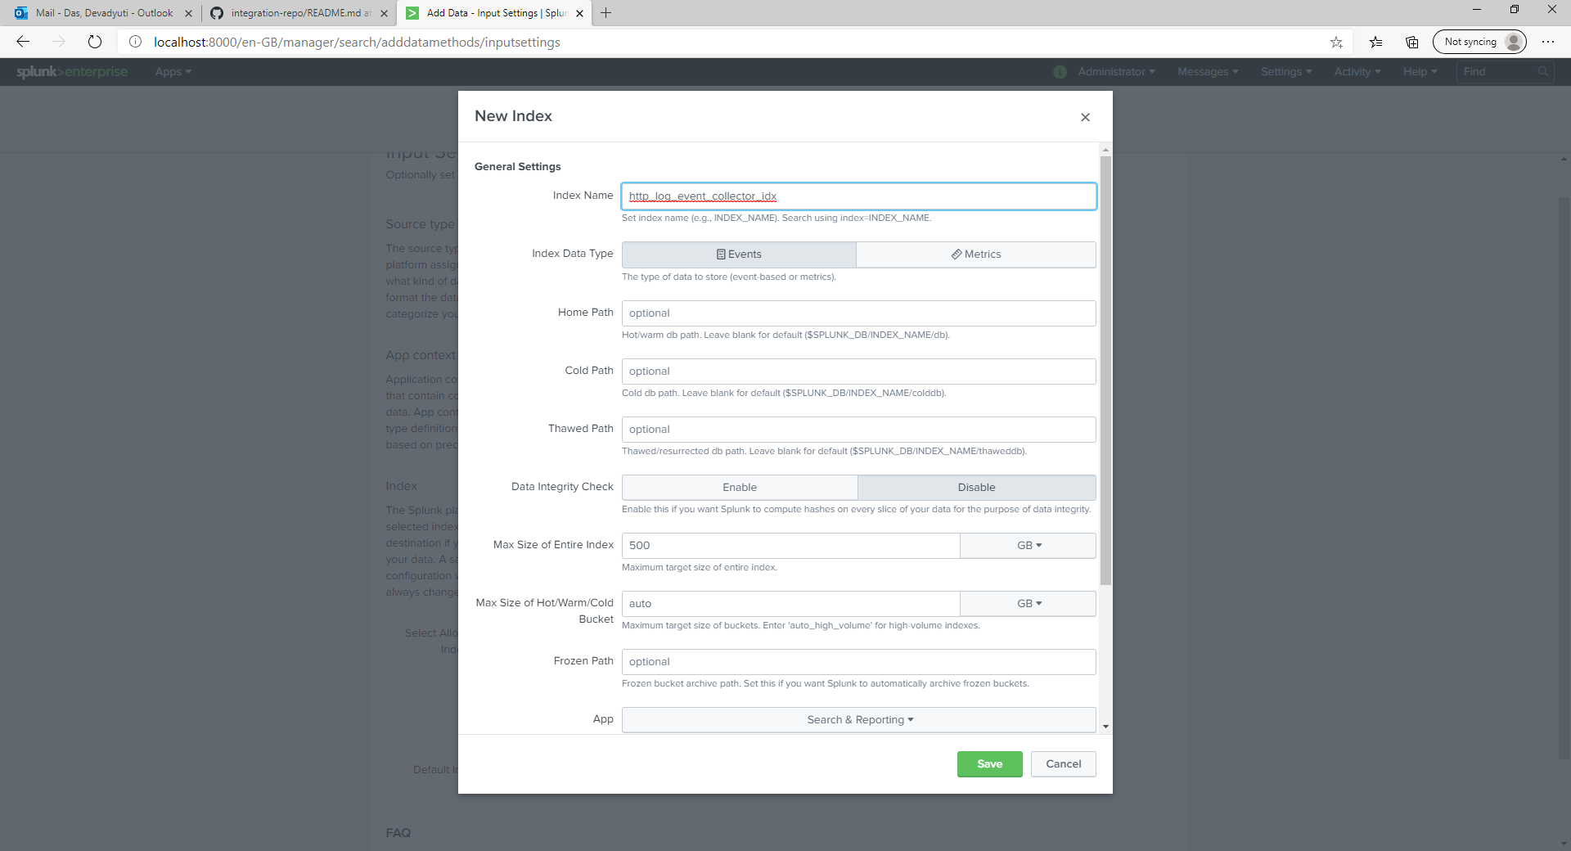

Select the Index from Available to Selected and click Review

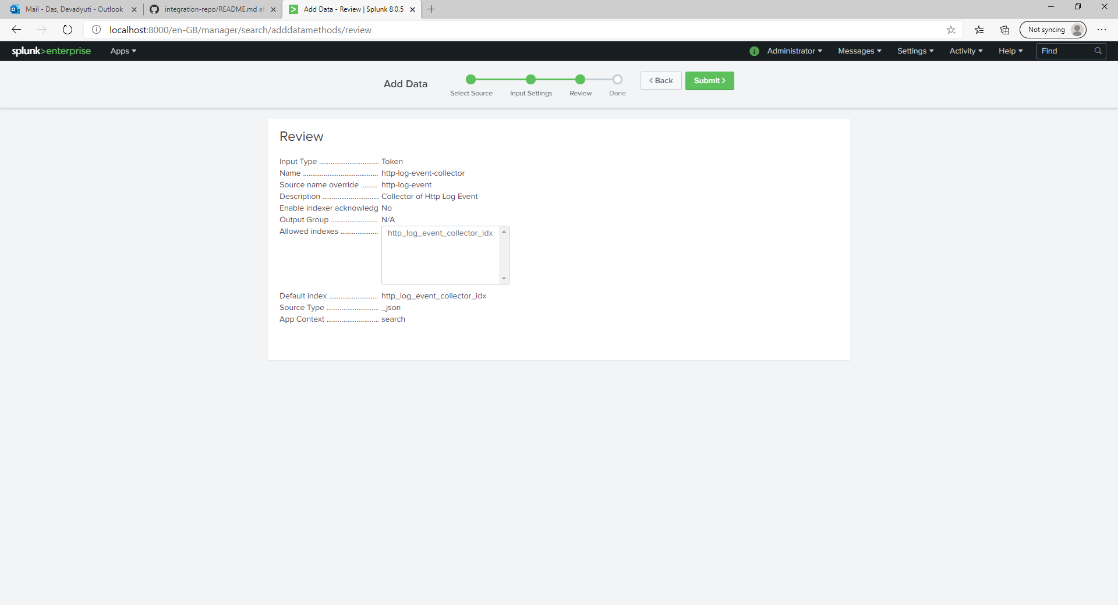

Hit Submit

Capture the token value from last page